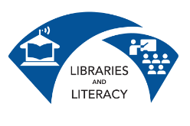
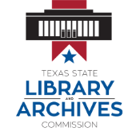
Course Descriptions
Do you need more help with computers? Do you need to upgrade their job hunting or work skills? Libraries and Literacy Technology Training can help! Ask your library or adult education school if they have Libraries and Literacy Trainers who can offer the classes listed below free of charge:
Computer Skills
Computer Basics is a two to four hour course designed to familiarize students new to computers with basic computer terminology, hardware, software, input (mouse and keyboard) and output (printer and external storage) devices, as well as the Microsoft Windows file structure.
Internet & Cyber-Safety is a two to four hour course designed to familiarize students with web browser basics, search engines, and search strategies. Ethical and safety concerns will also be considered.
Email is a two to four hour course designed to introduce students to email and other forms of electronic communication. Students will learn how to register for an email account, navigate an email interface, compose, send and receive messages, manage a contact list, and upload and download attachments. The course will also provide a brief overview of safety concerns and social networking.

Office Skills
Introduction to Microsoft Word is a two to four hour course designed to familiarize students with the common terminology, screen components and functions of Microsoft Word. Emphasis will be placed on proper document formatting techniques, file naming and file management conventions.
Introduction to Microsoft Excel is a two to four hour course designed to familiarize students with the common terminology, screen components and functions of Microsoft Excel. Emphasis will be placed on file naming and file management conventions. Students will create a working budget that they can save and use in their personal lives.
Finding Employment
Resume Writing is a two to four hour course designed to instruct students how to craft a resume for a 21st century job search. Students will learn how to use computer resources to write, format, and distribute a resume that accurately reflects their skills, experience, and educational background.
Online Job Search is a two to four hour course that will provide students with strategies to conduct an effective online job search. Students will learn how to access job sites on the web, use job search engines, and fill out online applications. The course also includes a self-evaluation of skills and tips on how to guard the jobseeker’s privacy during the job search.

